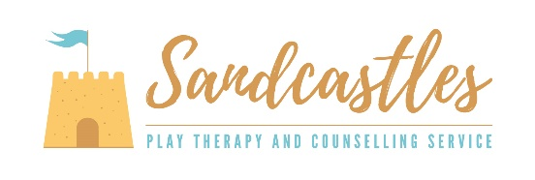

How do we refer?

* Arrange a chat with Miss Tymon (The SENDCo) on 01723 374 244.

Why might my child need play therapy?

Your child may have been touched by adverse childhood experiences including:

* Domestic violence
* Separation or divorce
* Bereavement
* A parent/family member with a mental health condition
* Victim of abuse or neglect
* A member of the household being in prison
* Growing up in a household where adults are experiencing alcohol and drug use problems
* Stressful events

Where are the sessions?

* At school.

What is play therapy?

* Highly focused play-based therapeutic sessions delivered over a 10/12 week period.
* Delivered by a certified member of PTUK and BACP.
* Sessions include a range of activities (sand, puppets, music, movement, role-play, clay, toys, arts and crafts).