|  |  |  |  |
| --- | --- | --- | --- |
| **Natural Rocks** | | | **Human-Made Rocks** |
| **Igneous** | **Sedimentary** | **Metamorphic** |
| Obsidian | Chalk | Marble | Brick |
| Granite | Sandstone | Quartzite | Concrete |
| Basalt | Limestone | Slate | Coade Stone |

|  |  |
| --- | --- |
| **Key Vocabulary** | |
| **igneous rock** | Rock that has been formed from **magma**  or **lava**. |
| **sedimentary rock** | Rock that has been formed by layers of **sediment** being pressed down hard and sticking together. You can see the layers of **sediment** in the rock. |
| **metamorphic rock** | Rock that started out as **igneous** or **sedimentary rock** but changed due to being exposed to extreme heat or pressure. |
| **magma** | Molten rock that remains underground. |
| **lava** | Molten rock that comes out of the ground is called **lava**. |
| **sediment** | Natural solid material that is moved and dropped off in a new place by water or wind, e.g. sand. |
| **permeable** | Allows liquids to pass through it. |
| **impermeable** | Does not allow liquids to pass through it. |

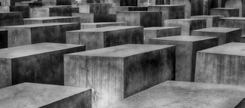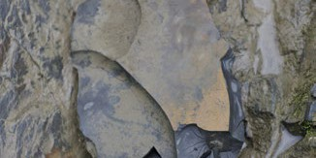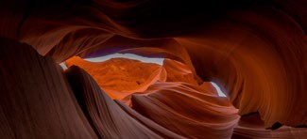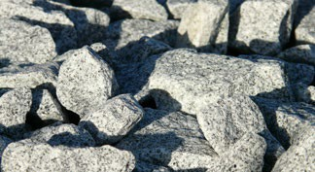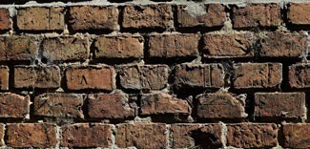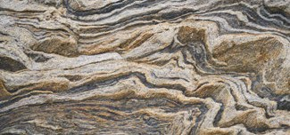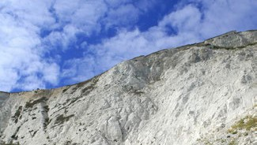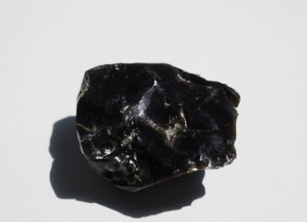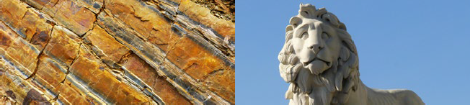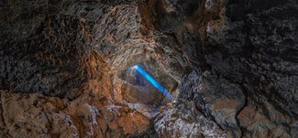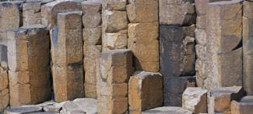

|  |  |  |  |  |
| --- | --- | --- | --- | --- |
| **Fossilisation** | | | | |
| An animal dies. It gets covered with **sediments** which eventually become rock. | More layers of rock cover it. Only hard parts of the creature remain, e.g. bones, shells and teeth. | Over thousands of years, **sediment** might enter the mould to make a **cast fossil**. Bones may change to mineral but will stay the same shape. | Changes in sea level take place over a long period. | As **erosion** and weathering take place, eventually the fossil becomes exposed. |
|  |  | C:\DS DAY FRIDAY\Fossil\Fossilisation-3.png | C:\DS DAY FRIDAY\Fossil\Fossilisation-6.png | C:\DS DAY FRIDAY\Fossil\Fossilisation-7.png |

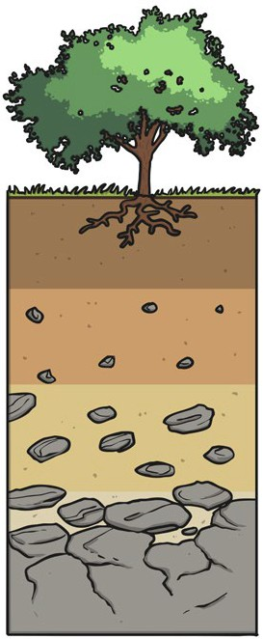

|  |  |
| --- | --- |
| **Key Knowledge** | |
| **Soil** | |
| Soil is the uppermost layer of the Earth. It is a mixture of different things:   * minerals   (the minerals in soil come from finely broken-down rock);   * air; * water; * organic matter (including living and dead plants and animals). |  |

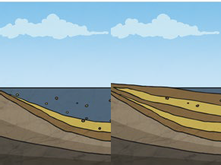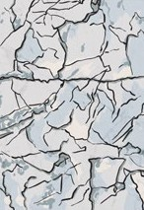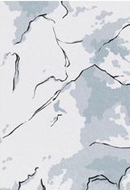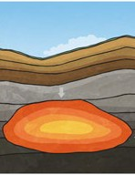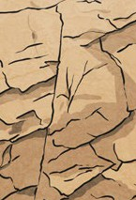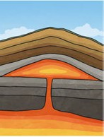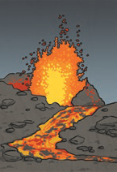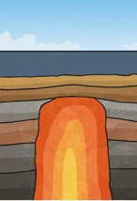

**Sedimentary**

**Igneous**

**Metamorphic**

There are three types of naturally occurring rock.

**Key Knowledge**

|  |
| --- |
| Some words you might use to discuss the  properties of a rock: |
| hard, soft, **permeable**, **impermeable**, durable  (Meaning resistant to weathering), high density,  low density. Density measures how ‘bulky’ the  rock is (how tightly packed the molecules are). |

|  |  |
| --- | --- |
| **fossilisation** | The process by which fossils are made. |
| **palaeontology** | The study of fossils. |
| **erosion** | When water, wind or ice wears away land. |

Topsoil

Subsoil

bedrock