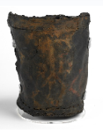[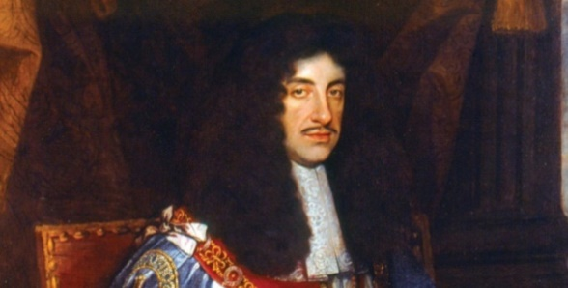](https://www.google.co.uk/url?sa=i&url=https://moneyweek.com/393340/29-may-1660-charles-ii-restored-to-the-throne/&psig=AOvVaw3XmxFfv6pWOIoUzfW3bNSN&ust=1576157474396000&source=images&cd=vfe&ved=0CAIQjRxqFwoTCOjNsKbareYCFQAAAAAdAAAAABAD)

Where is London?

leather buckets

How does modern London compare to London in Tudor times?

Where did the Great Fire start?

**The Great Fire of London**

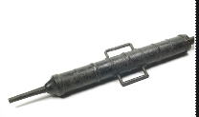

water squirt

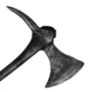[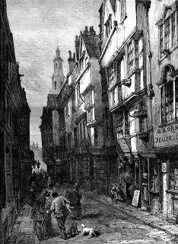](https://www.telegraph.co.uk/travel/destinations/europe/united-kingdom/england/london/articles/medieval-london/)

1666

[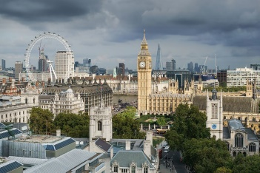](https://www.google.co.uk/url?sa=i&rct=j&q=&esrc=s&source=images&cd=&ved=2ahUKEwihlbLx2bzmAhWRMBQKHZHTCZUQjRx6BAgBEAQ&url=https://en.wikipedia.org/wiki/London&psig=AOvVaw0ytNlHDlp2s111M5pDCqkR&ust=1576672743032007)[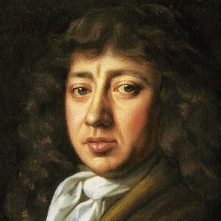](https://www.google.co.uk/url?sa=i&url=https://twitter.com/samuelpepys/status/1161203383426064385&psig=AOvVaw2Q51r6hWdDeeEc1ZvQI-pl&ust=1576157565656000&source=images&cd=vfe&ved=0CAIQjRxqFwoTCOC6z9HareYCFQAAAAAdAAAAABAO)

axe

King Charles II

Tower of London

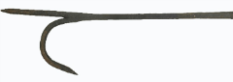

fire hook

2019

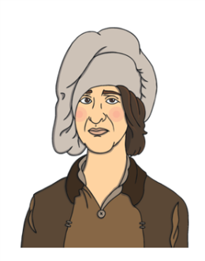

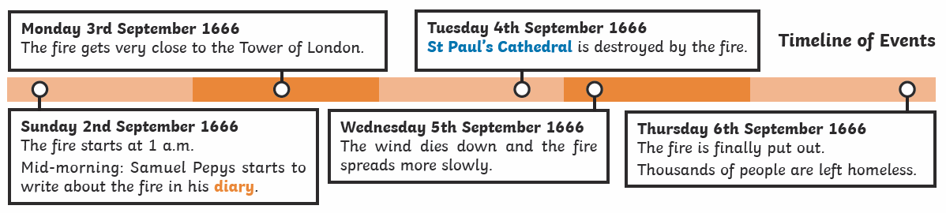

Samuel Pepys

Pudding Lane

Thomas Farriner

