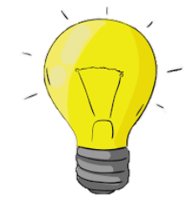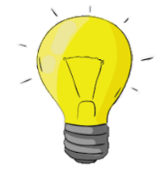

**LIGHT**

KNOWLEDGE ORGANISER

Y6

**Vocab:** light source eye pupil reflection mirror shadow opaque transparent dark

Our eyes have a small window at the front called a pupil, through which light can enter. The pupil looks as though it is black because it is dark inside our eyes.

|  |  |  |  |  |  |  |  |
| --- | --- | --- | --- | --- | --- | --- | --- |
| **What you should already know…** | |  | **How Light Travels** | | | | |
| -Light is a form of energy that makes it possible to see.  Light is given off some objects (for example the Sun). Darkness is the absence of light.  -Light can reflect off surfaces (e.g. mirrors). Light is absorbed by other materials.  -Objects can be labelled as transparent, translucent, or opaque, depending on the amount of light that they let through.  -Shadows are formed when light is blocked by an opaque object. | |  |  |  | -Light originates from light sources.  -Light sources can be natural (e.g. The Sun, the stars) or man-made (e.g. street lamp, Christmas tree lights, glow stick, mobile phone, TV).  -Light travels in a straight line from light sources.  -We can see that light travels in straight lines when we shine a torch in a dark room, or when a ray of light comes through a window.  -When an object passes in front of a ray of light, the light can be blocked, creating a shadow.  -Opaque objects let no light through (creating the darkest shadows), translucent objects let some light through (creating fainter shadows), transparent objects let all light through (no shadow). |  | |
|  |
|  |  |  |
| **How We See Things** | |  |
| -We see things because…  a.) they are a light source, sending light into our eyes, or  b.) light is reflected from a light source off them and into our eyes.  When the light enters our eyes, we see the object!  -For example, we see The Sun because it is a light source, sending light into our eyes.  -However, The Moon is not luminous (does not produce its own light). We see it because light from The Sun reflects off it into our eyes.  - After light reflects off objects, it continues to travel in a straight line, but in a new direction. | |  |  |  |  |
|  | | | | |
| Our Eyes | | | | |
|  |  |  |  |  | |
|  |  |  |  |  | |
|  |  | -When it is dark, our pupils go larger, in order to let more light in so that we can see better. In bright lights, our pupils go smaller.  -At the back of our eye is a sensitive sheet of nerves called a retina. They can detect light when it comes in through the pupil, and send messages to the brain about what we can see. |  | |
|  |  |  |  |  | |
|  |  | |
|  |  |  |  |  | |

Light Spectrum

Green

Indigo

Blue

Yellow

Orange

Violet

Red